EEM211 MIDTERM ANSWERS 20.11.2006

1. Answer The Following Questions

a) 9E36.7AH = ?₂ = ?₈

Since the given number is Hexadecimal, we may convert it into binary by writing each digit in 4-bits binary.

(9E36.7A)₁₆ = (1001111000110110 . 01111010)₂

Now, by rearranging the number in 3-bits groups, we may find its corresponding octal number:

(001 001 111 000 110 110 . 011 110 100)₂ = (117066 . 364)₈

- Decimal 3 is expressed as 0110 in a self-complementing code alphabet. Find the corresponding code for decimal 6, in the same alphabet.

The property of self-complementing codes is that, the 9’s complement of a given number can be found by complementing each bit. Since the 9’s complement of 3 is 6, it should be obtained by complementing each bit of 3, which is 1001.

- What is the smallest number that can be represented in 6-bit signed 2’s complement form? Is it the same in 6-bit signed 1’s complement representation? Why?
-32 (100000), is the smallest number that can be represented in 6 bit signed-2’s complement form. In 1’s complement form, it becomes –31 olur (100000), since one of the combinations (111111) is used for –0, which is not available in 2’s complement .

d ) Find the corresponding Hamming Code for the 4-bit message 1101. Show all of your steps clearly.

Position: 1 2 3 4 5 6 7
Received Word: p₁ p₂ 1 p₃ 1 0 1 (message bits are in bolds)

4,5,6,7 Parity Check: Even → p₃ = 0
2,3,6,7 Parity Check: Even → p₂ = 0
1,3,5,7 Parity Check: Odd → p₁ = 1

Coded Word: 1010101

e ) Given F(x,y,z) = x’y’+ x’z. Find F’(x,y,z) in canonical S.O.P and P.O.S forms and express them in ∏ and ∑ standard formats.

x y z F=x’(y’+z) F’
F’ (x,y,z) = ∑ (2, 4, 5, 6, 7)
= ∏ (0, 1, 3)
0 0 0 0 1 0
1 0 0 1 1 0
2 0 1 0 0 1
3 0 1 1 1 0
4 1 0 0 0 1
5 1 0 1 0 1
6 1 1 0 0 1
7 1 1 1 0 1

2 - Answer The Following Questions

  - Given A = (00011001)₂ and B = (11010010)₂. Show how A+B, A-B, -A-B and B-A would be computed, using 8-bit two’s complement arithmetic, step by step separately.
A = (25)₁₀ = (00011001)_{2 ,} B = (11010010)_{2 ,} -A = 11100111, -B = 00101110,

A+B = 11101011 = -21,
A-B = (01000111) = 71 ,
B-A= 10111001 =- -71
-A-B = (-A)+(-B) = 00010101 =21

b) Draw the output waveforms S and C (into the given spaces) of the Full Adder, that would be generated in response to the given input signals

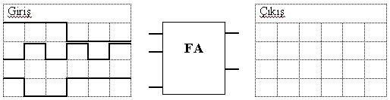
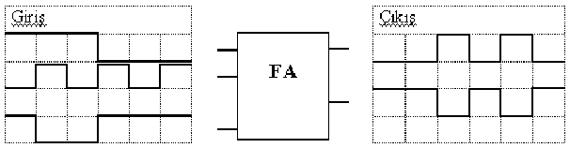
S
C_{o}
C_{i}
A
B

3) F(A,B,C,D) = Σ (0,1,2,3,4,8,9,12) Implement this function using two level NAND – AND form with minimum logic gates.

CD
AB | 00 | 01 | 11 | 10  Selecting 0’s to write F’ we find:  F’(A,B,C,D) = BD + BC + AC which can be realised in AND-OR-INVERT form:
00 | 1 | 1 | 1 | 1
01 | 1 | 0 | 0 | 0
11 | 1 | 0 | 0 | 0
10 | 1 | 1 | 0 | 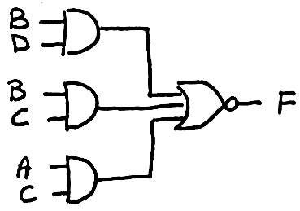  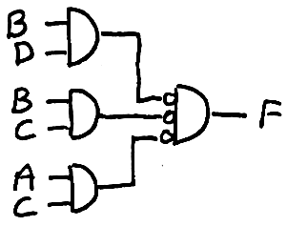  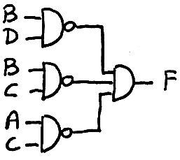  0

AND-OR-INVERT NAND-AND

4) Design a 4-input, 1-output logic circuit, that will receive BCD numbers at its input and generate an output of 1, if the received number is ≥ 5, an output of 0 otherwise. Realize your circuit in AND – OR form, with minimum number of gates/inputs, without any inverter. Repeat your design in NOR – NOR form. NOTE: The inverted inputs are not available.

 | A | B | C | D | F
0 | 0 | 0 | 0 | 0 | 0
1 | 0 | 0 | 0 | 1 | 0
2 | 0 | 0 | 1 | 0 | 0
3 | 0 | 0 | 1 | 1 | 0
4 | 0 | 1 | 0 | 0 | 0
5 | 0 | 1 | 0 | 1 | 1
6 | 0 | 1 | 1 | 0 | 1
7 | 0 | 1 | 1 | 1 | 1
8 | 1 | 0 | 0 | 0 | 1
9 | 1 | 0 | 0 | 1 | 1
10 | 1 | 0 | 1 | 0 | X
11 | 1 | 0 | 1 | 1 | X
12 | 1 | 1 | 0 | 0 | X
13 | 1 | 1 | 0 | 1 | X
14 | 1 | 1 | 1 | 0 | X
15 | 1 | 1 | 1 | 1 | X

A
BC
BD
CD\AB | 00 | 01 | 11 | 10
00 | 0 | 0 | X | 1
01 | 0 | 1 | X | 1
11 | 0 | 1 | X | X
10 | 0 | 1 | X | X

The truth table and Karnaugh maps of the required function are shown at the right and up, respectively. If we select the 1’s in the map, we can write:
F(A,B,C,D) = A + BC + BD which can be directly realized as shown in Fig. A.

Now, if we select 0’s, we can write:
F(A,B,C,D) = (A+B)(A+C+D) which can be realized in OR-AND form and then by adding cancelling bubles it can easily be converted into NOR-NOR form, as shown in Fig.B

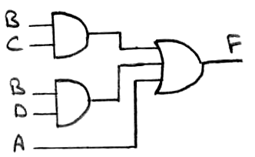
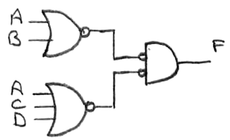

Figure A Figure B

5) Find a simplified (minimized) expression and draw your new circuit, for the logic circuit below:
